**Relational Database**

**Implementation of Omniplex Cinema**



**Student ID:** 20075871

**Name:** Conor Power

**Date:** 02/12/2017

**Module:** Relational Databases

**Table of Contents**

**Contents** **Page Number**

1. Introduction to Project 1
2. Normalized Tables 1
3. EER Diagram 1
4. Table Mapping 2
5. SQL Implementation 3

**Introduction to Project:**

This project serves as a report on the implementation for the database which was designed, planned, and illustrated in an Enhanced Entity Relationship Diagram as a part of a project design document for CA1. The normalised tables, table mapping, SQL statements and SQL queries were created as a part of this project.

**Normalization:**

* Department (Name, Number of Employees)
* Employee (Employee ID, Name, Phone Number, Date Started, Salary, Department)
* Cinema (Cinema ID, Phone Number, Address, Number of Screens)
* Ticket (Ticket Number, Ticket Cost, Movie Title)
* Customer (Customer ID, Name, Movie Title, Age)
* Transaction (Transaction Number)
* Movie (Movie ID, Movie Title, Theatre Number, Date Released, Director, Producer, Age Restriction)
* Movie Schedule (Movie ID, Date, Time)
* Theatre (Theatre Number, Capacity)

**Enhanced Entity Relationship Diagram:**

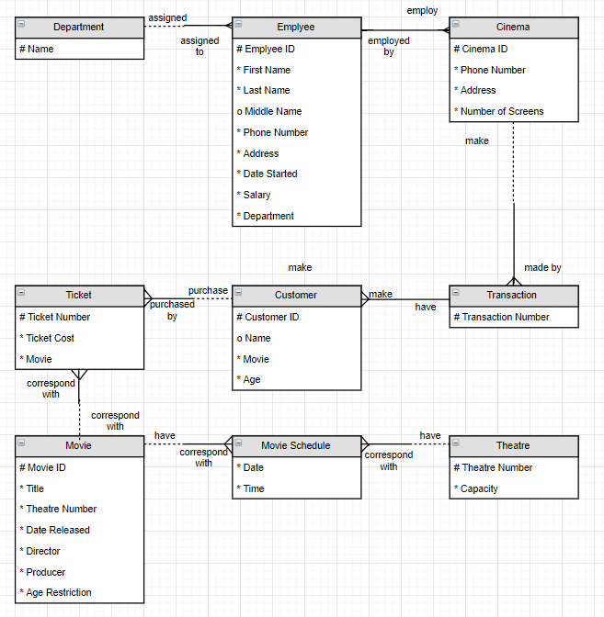

**Table Mapping:**

